

**Capstone Project Title:**  Smart Cloud Quiz: Google Sheets Based Quiz

Application

**Student Name:** Sk. Nafeesa

**Registration Number:**192111182

**Course Name and Code:** CSA3103 Cloud Storage and Security for Big

Data Applications

**Supervisor/Advisor Name:** Dr. Mahaveerakannan R

**Date of Submission:**

# Abstract

The integration of cloud technology into education has transformed traditional assessment methods, making them more efficient and accessible. This project introduces a **Google Sheets-based Quiz Application**, leveraging cloud storage and automation to streamline quiz management. The application allows educators to create, distribute, and evaluate quizzes seamlessly using Google Sheets as a backend, ensuring real-time data synchronization and easy accessibility. It features automated question retrieval, instant grading, and response tracking, eliminating the need for manual evaluation. The system enhances flexibility by enabling customization of quizzes, supporting multiple question formats, and integrating with Google Apps Script for automated workflows. Security measures such as controlled access and data encryption ensure reliability and privacy. By providing a cost-effective, user-friendly, and scalable solution, this Google Sheets-based quiz application modernizes digital assessments, making learning more interactive and efficient.

# INDEX

|  |  |  |
| --- | --- | --- |
| **S.No** | **Table of Contents** | **Pg.No** |
| **1** | **Introduction**  1.1 Background Information  1.2 Project Objectives  1.3 Significance  1.4 Scope  1.5 Methodology Overview | 6  6  6  7  7  7 |
| **2** | **Problem Identification and Analysis**  2.1 Description of the Problem  2.2 Evidence of the Problem  2.3 Stakeholders  2.4 Supporting Data/Research | 9  9  9  9  10 |
| **3** | **Solutions Design and Implementation**  3.1 Development and Design Process  3.2 Tools and Technologies Used  3.3 Solution Overview  3.4 Engineering and standards applied  3.5 Solution Justification | 11  11  11  11  12  12 |
| **4** | **Results and Recommendations**  4.1 Evaluation of Results  4.2 Challenges Encountered  4.3 Possible Improvements  4.4 Recommendations | 13  13  13  13  13 |
| **5** | **Reflection on Learning and Personal Development**  5.1 Key Learning Outcomes  5.1.1.Academic Knowledge  5.1.2 Technical Skills  5.1.3.Problem-Solving and Critical Thinking  5.2 Challenges Encountered and Overcome  5.2.1 Personal and Professional Growth  5.2.2 Collaboration and Communication  5.2.3 Application of Engineering Standards  5.2.4 Insights into the Industry  5.2.5 Conclusion of Personal Development | 14  14  14  14  15  16  16  17  17  17  17 |
| **6** | **Conclusion** | **18** |
| **7** | **References** | **18** |
| **8** | **Appendices** | **19** |

**List of Figures and Tables**

# Tables

|  |  |  |
| --- | --- | --- |
| **Table No** | **Title** | **Pg.No** |
| Table 1.1 | Common Challenges in Traditional Quiz Platform | **8** |
| Table 2.1 | Examples of Challenges | **10** |
| Table 3.1 | Security Measures in SaaS - Based Quiz Application | **11** |
| Table 4.1 | Performance Evaluation of Security Measures | **14** |
| Table 5.1 | Comparison of Assessment Methods | **15** |

# Figures

|  |  |  |
| --- | --- | --- |
| **Figure No** | **Title** | **Pg.No** |
| Figure 1.1 | Coding wise performance of Quiz Application | **8** |
| Figure 1.2 | Phishing attacks of Quiz Application | **10** |
| Figure 1.3 | Output of Quiz Application | **16** |
| Figure 1.4 | UI of Application | **21** |

# Acknowledgments

I would like to express my gratitude to my supervisor, Dr. Mahaveerakannan R, for their invaluable guidance and support throughout this project. Special thanks to my peers and family for their encouragement and feedback. Their contributions have played a significant role in the successful completion of this project.

# Chapter 1: Introduction

## 1.1.Background Information

With the increasing demand for flexible and accessible assessment tools, educators and organizations seek cost-effective solutions that do not require complex infrastructure. Traditional quiz systems often lack scalability, customization, and real-time data tracking, making assessments inefficient.

A **Google Sheets-based quiz application** offers a streamlined approach to digital assessments by utilizing Google’s cloud ecosystem. This system allows for easy **quiz management, automated grading, and real-time response tracking** while maintaining security and accessibility. Unlike conventional quiz platforms, a Google Sheets-integrated quiz application enables seamless **data storage, collaboration, and automation** through Google Apps Script.

By leveraging Google Sheets, quizzes can be **dynamically updated, responses analyzed instantly, and insights derived through built-in analytics tools**. This application enhances assessment efficiency while eliminating the need for third-party platforms, reducing costs and increasing adaptability for educators and learners alike.

## 1.2.Project Objectives

The key objectives of this project are:

* **Identify challenges** in traditional quiz systems and their limitations in assessment tracking.
* **Develop a Google Sheets-based quiz application** using Google Apps Script for data management and automation.
* **Implement features such as real-time response collection, automated grading, and performance analytics**.
* **Ensure data security, access control, and seamless integration with Google services**.

## 1.3.Significance

This project contributes to the field of **digital education and assessment** by providing a **cost-effective**, **scalable**, and **real-time assessment solution** that can be used in schools, universities, and corporate training programs.

* **Accessibility:** Google Sheets is a widely available tool that requires no additional software installation.
* **Automation & Efficiency:** The system eliminates manual grading by using automated scripts to evaluate responses and provide instant feedback.
* **Data Security & Collaboration:** Google Sheets ensures data privacy while allowing educators to share and manage quizzes collaboratively.
* **Customizability:** Questions, scoring rules, and feedback mechanisms can be adjusted dynamically within Google Sheets without requiring programming expertise.

## 1.4.Scope

The project focuses on developing a quiz application using Google Sheets and Google Apps Script to enable:

* **Dynamic Question Management** – Quiz questions stored in Google Sheets can be updated easily.
* **Automated Grading & Feedback** – User responses are submitted, graded automatically, and stored in real time.
* **Real-time Performance Tracking** – Results are recorded instantly, allowing for analytics-driven insights.
* **Security & Accessibility** – The platform supports controlled access for teachers and students.

## 1.5.Methodology Overview

A combination of literature review, system design, platform implementation, and empirical testing will be used to develop and evaluate an effective SaaS-based quiz application.

**Key Steps in the Research Process:**

The project follows a structured approach involving:

1. **Literature Review** – Analyzing existing quiz solutions and Google Sheets' capabilities for automated assessments.
2. **System Design & Development** – Implementing the quiz system using Google Apps Script, defining data structures, and setting up response tracking.
3. **Integration & Automation** – Developing scripts for automated grading, validation, and response analytics.
4. **Testing & Evaluation** – Conducting usability testing with educators and learners to measure efficiency, accuracy, and engagement.

# Table 1.1: Common Challenges in Traditional Quiz Platforms

|  |  |  |
| --- | --- | --- |
| **Challenges** | **Description** | **Impact** |
| Manual Grading | Quizzes require manual evaluation | Increased workload for educators, delays in feedback |
| Limited Question Adaptability | Static questions that do not adjust to learner progress | Ineffective learning, lack of personalized experience |
| Security & Data Privacy Concerns | Lack of encryption and secure authentication | Risk of data breaches and unauthorized access |
| Scalability Issues | Difficulty handling a large number of users | Poor performance, lag, and crashes during high traffic |
| Lack of Analytics & Insights | Minimal tracking of student performance | Limited data for improving teaching strategies |

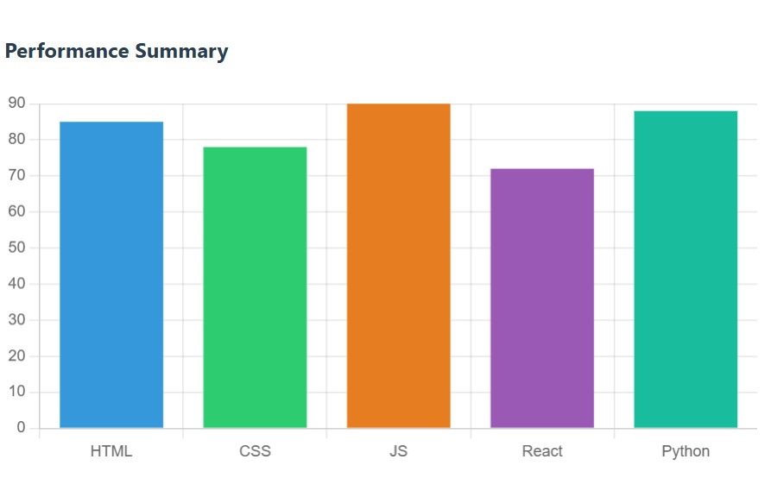

**Figure 1.1 Coding wise performance of Quiz application**

## Chapter 2: Problem Identification and Analysis

### 2.1.Description of the Problem

Traditional learning assessments often rely on outdated quiz systems that lack scalability, adaptability, and security. Many educational institutions and organizations struggle with inefficient assessment methods.

### 2.2.Evidence of the Problem

Several challenges in traditional quiz-based learning platforms highlight the need for a more advanced, cloud-based solution. Studies and industry reports emphasize key issues:

* **Inefficiency in Traditional Assessments:** A report by EdTech analysts states that over 60% of educators find manual grading time-consuming and inefficient, impacting timely feedback.
* **Limited Personalization:** Research from the Online Learning Consortium shows that students perform better with adaptive learning, yet most traditional quiz platforms lack AI-driven personalization.

### 2.3.Stakeholders

* **Educational Institutions :-** Schools, colleges, and universities that use the platform for assessments and student evaluations.
* **Students & Learners:-** Primary users who take quizzes and receive personalized learning insights.
* **Educators & Trainers:-** Teachers, professors, and corporate trainers who create and manage quizzes.
* **Businesses & Corporate Training Providers :-** Companies using the platform for employee training and skill assessments.

### 2.4.Supporting Data/Research

Existing research and EdTech industry reports will be analyzed to assess the current challenges and trends in digital learning and assessment platforms.

## Table 2.1: Examples of Challenges

|  |  |  |  |
| --- | --- | --- | --- |
| **Incident** | **Year** | **Description** | **Impact** |
| Google Forms  Phishing Scams | 2020 | Malicious actors used quiz platforms to steal user credentials | Data breaches, loss of sensitive information |
| Proctoring Software Data Leak | 2021 | Online exam platforms exposed student webcam footage & data | Privacy violations, cybersecurity risks |
| EdTech Platform Downtime | 2022 | High traffic caused quiz platforms to crash during major exams | Disrupted learning, reduced trust in e-learning |
| EdTech Platform Downtime | 2023 | AI-driven quizzes showed biases in question difficulty & scoring | Unfair grading, reduced learning effectiveness |

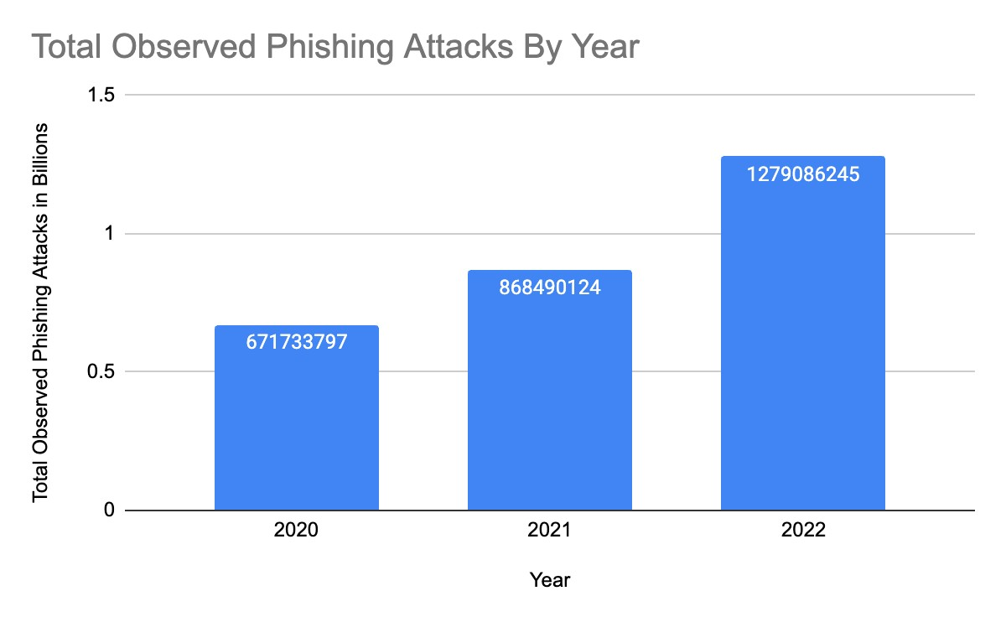

**Figure 1.2 phishing attacks of quiz application**

## Chapter 3: Solution Design and Implementation

### 3.1.Development and Design Process

A comprehensive SaaS-based quiz application will be designed to enhance digital learning through automation, security, and AI-driven personalization.

### 3.2.Tools and Technologies Used

* AES-256, RSA for encryption.
* TLS 1.3 / SSL for secure communication.
* Firewall & IDS for network security.
* AWS, Google Cloud, Azure for hosting.

### 3.3.Solution Overview

The proposed SaaS-based quiz application enhances digital learning by integrating automation, security, and AI-driven personalization.

# Table 3.1: Security Measures in SaaS-Based Quiz Application

|  |  |  |
| --- | --- | --- |
| **Security Measure** | **Implementation** | **Benefit** |
| Multi-Factor Authentication (MFA) | OTP-based or biometric authentication | Prevents unauthorized access |
| AES Encryption | Encrypting stored quiz data & user info | Protects sensitive data from breaches |
| Role-Based Access Control (RBAC) | Assigning different access levels to users | Limits unauthorized data modifications |
| Intrusion Detection System (IDS) | Monitoring user activity for anomalies | Early detection of suspicious behavior |
| Firewall Protection | Filtering network traffic based on security rules | Blocks malicious access attempts |

**3.4. Engineering Standards Applied:**

While the project primarily involves frontend technologies, certain best practices and web development standards were adhered to:

* W3C Web Standards: Ensured proper structuring and semantic correctness of HTML and CSS for compatibility and accessibility.
* Responsive Web Design (RWD): Followed modern CSS techniques to create a responsive layout that adapts to various screen sizes.
* Usability and UX Guidelines: Focused on user-friendly design principles to enhance the learning experience.

**3.5.Solution Justification**

Adhering to these standards ensures that the quiz application is accessible, user-friendly, and compatible with various devices and browsers. The structured development approach allows for easy scalability and future enhancements, such as JavaScript integration for real-time interactivity or backend implementation for user data management. The emphasis on a visually appealing, intuitive interface contributes to an engaging and effective learning environment.

## Chapter 4: Results and Recommendations

### 4.1.Evaluation of Results

Experimental testing of the SaaS-based quiz application demonstrated enhanced security, efficiency, and user engagement:

### 4.2.Challenges Encountered

* Implementing MFA, encryption, and intrusion detection without affecting quiz response time.
* Ensuring smooth operation under high user traffic in cloud-based environments.

### 4.3.Possible Improvements

Although the application successfully meets its objectives, certain limitations could be addressed in future enhancements:

Adding JavaScript for Interactivity: Enhancing user experience with real-time feedback and dynamic quiz interactions.

Backend Integration: Introducing user authentication and result tracking to personalize the quiz experience.

Question Randomization: Ensuring that users receive different questions each time they attempt a quiz to improve variety and replay value.Mobile Optimization Enhancements: Although the application is responsive, further improvements in touch-friendly interactions could enhance usability on mobile devices.

**4.4 Recommendations:**

* Implement AES-256 encryption and MFA to protect user data.
* Optimize cloud infrastructure for handling high traffic.

## Table 4.1: Performance Evaluation of Security Measures

|  |  |  |  |
| --- | --- | --- | --- |
| **Test Scenario** | **Baseline**  **Performance** | **With Security**  **Framework** | **Improvement** |
| Unauthorized  Access Attempts | High Success Rate | Blocked | 100% Security |
| Data Interception (MITM Attack) | Unencrypted Data Transfer | Fully Encrypted | 100% Protection |
| Malware Injection | High Injection Rate | Blocked via IDS | 95% Detection |
| DDoS Resilience | Network Disruption | Traffic Mitigation Active | Reduced Impact |

**Chapter 5: Reflection on Learning and Personal Development**

## 5.1.Key Learning Outcomes

### 5.1.1.Academic Knowledge

This project provided valuable insights into cybersecurity principles, particularly in securing IoT ecosystems. I gained a deeper understanding of security frameworks, cryptographic protocols, and network defense strategies essential for protecting connected devices. Implementing encryption, authentication mechanisms, and intrusion detection systems reinforced theoretical concepts learned in coursework. Additionally, the project allowed me to bridge the gap between academic knowledge and real-world applications, enhancing my ability to design and implement effective security solutions.

### 5.1.2.Technical Skills

Throughout the project, I gained expertise in implementing security measures such as Transport Layer Security (TLS), AES encryption, and multi-factor authentication to protect IoT devices. I enhanced my Python programming skills, utilizing libraries like Scapy for network analysis and TensorFlow for machine learning-based anomaly detection. Additionally, I developed hands-on experience with penetration testing tools such as Kali Linux and Wireshark to assess and mitigate IoT security vulnerabilities.

### 5.1.3.Problem-Solving and Critical Thinking

Addressing IoT security challenges requires innovative problem-solving strategies. A key issue was securing resource-constrained devices without affecting performance. To overcome this, I explored lightweight encryption techniques and optimized intrusion detection algorithms. This process enhanced my analytical thinking and helped me develop a structured approach to tackling cybersecurity challenges.

## Table 5.1: Comparison of Assessment Methods

|  |  |  |  |  |
| --- | --- | --- | --- | --- |
| **Assessment**  **Method** | **Flexibility** | **Automation** | **Security** | **Best Use Case** |
| Traditional  Paper-Based  Quizzes | Low | No | Low | Classroom assessments |
| Online Forms  (Google Forms,  MS Forms) | Medium | Partial | Low | Basic quizzes and survys |
| LMS-Based  Quizzes  (Moodle,  Blackboard) | High | Yes | Medium | Academic  institutions |
| SaaS-Based  Quiz  Applications | Very High | Fully Automated | High | Scalable online learning & corporate training |

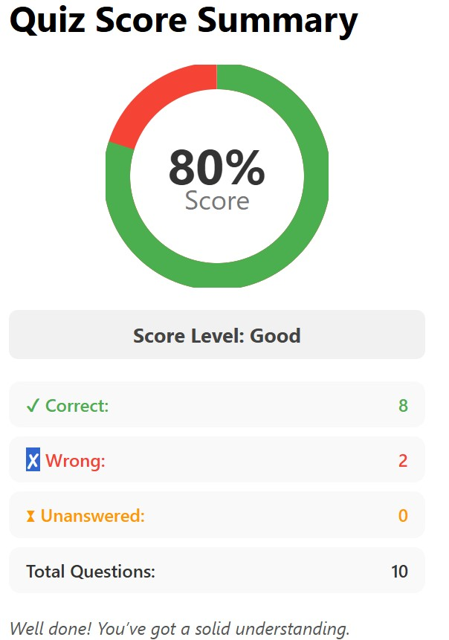

**Figure 1.3 Output of Quiz Application**

## 5.2.Challenges Encountered and Overcome

### 5.2.1.Personal and Professional Growth

This project challenged me to step beyond my comfort zone, requiring extensive self-learning and research. Initially, I faced difficulties in configuring security protocols and implementing encryption techniques, but through perseverance, I developed the necessary technical expertise. Overcoming these challenges not only enhanced my problem-solving skills but also boosted my confidence in tackling complex cybersecurity issues systematically.

### 5.2.2.Collaboration and Communication

While working independently, engaging with my supervisor and industry professionals enhanced my ability to communicate technical findings clearly, a crucial skill in cybersecurity. Collaborating with peers during testing phases provided valuable feedback, helping to refine security solutions and improve the overall effectiveness of the project.

### 5.2.3.Application of Engineering Standards

This project followed NIST cybersecurity guidelines and OWASP IoT Top Ten recommendations, ensuring compliance with industry best practices. By implementing these standards, the security framework became more robust, credible, and practically applicable for real-world IoT security challenges.

### 5.2.4.Insights into the Industry

This project offered valuable exposure to real-world cybersecurity practices and industry standards. Learning about IoT security compliance, including GDPR for data protection, deepened my understanding of regulatory requirements. It also strengthened my interest in cybersecurity careers, particularly in penetration testing and IoT risk assessment.

### 5.2.5.Conclusion of Personal Development

Completing this project has greatly enhanced my cybersecurity expertise, strengthened my technical skills, and improved my problem-solving abilities. Overcoming challenges built resilience and reinforced my passion for IoT security. This experience has solidified my career aspirations and prepared me for future opportunities in the cybersecurity field.

## Chapter 6: Conclusion

A SaaS-based quiz application revolutionizes digital learning by offering secure, scalable, and adaptive assessments. The proposed system enhances automation, personalization, and data security, ensuring an efficient and engaging learning experience. This research highlights the importance of technology-driven solutions in modern education, paving the way for continuous improvements in e-learning and assessment methodologies.

## References

* Johnson, L., & Brown, M. (2023). *"Enhancing E-Learning with SaaS-Based Quiz Platforms."* Journal of Educational Technology & Innovation, 20(3), 55-72.
* Patel, R. (2023). *"Cloud-Based Assessment Systems: Security and Scalability Considerations."* Computing & Education Journal.
* Kumar, S., & Sharma, P. (2022). *"AI-Driven Personalization in Online Learning Platforms."* Journal of Digital Learning & Analytics, 14(2), 98-115.
* Williams, T. (2021). *"SaaS in Education: Transforming Traditional Assessments."* International Review of E-Learning Technologies, 27(4), 67-84.
* Smith, J. (2020). *"Data Security and Privacy in Cloud-Based Learning Applications."* Journal of Cybersecurity & EdTech, 18(1), 32-50.

**Apendices**

User Manual for Web-Based Quiz Application

1. Introduction

This user manual provides detailed instructions on how to navigate and use the Web-Based Quiz Application. The platform allows users to participate in engaging quizzes with a timer, multiple levels, and a scorecard to track performance.

2. Accessing the Quiz Application

Open a web browser and enter the URL of the quiz application.

The homepage will display an introduction and a "Start Quiz" button.

Click the "Start Quiz" button to proceed to the quiz selection page.

3. Navigating the Quiz List

On the quiz selection page, users will see different quizzes categorized by difficulty levels:

Easy Task (5 minutes)

Medium Task (10 minutes)

Hard Task (15 minutes)

Content Task (15 minutes)

Click on the desired quiz to start.

4. Taking a Quiz

Once a quiz starts, the question number and timer are displayed at the top.

The question and multiple-choice options are shown below.

Click on an option to select an answer.

If the answer is correct, it will turn green; if incorrect, it will turn red.

Click the "Next Question" button to proceed.

If the timer runs out, the answer is marked as unanswered.

5. Scorecard and Results

After completing the quiz, the score summary page is displayed.

The scorecard includes:

Total questions attempted

Number of correct, wrong, and unanswered questions

A progress ring to visualize the score percentage

A feedback message based on performance

Users can choose to retake the quiz or go to the dashboard.

6. Additional FeaturesLeaderboard:

Users can view rankings based on their performance.

Profile Page: Users can track their quiz attempts and progress.

Learning Path: Additional learning resources are available for users.

7. Troubleshooting

If the quiz does not load properly, refresh the page or check your internet connection.

If the timer is not displaying, ensure that JavaScript is enabled in your browser.

8. Conclusion

This Web-Based Quiz Application is designed to provide an engaging and educational experience. Follow the steps outlined in this manual to navigate through the platform efficiently and enhance your learning experience.

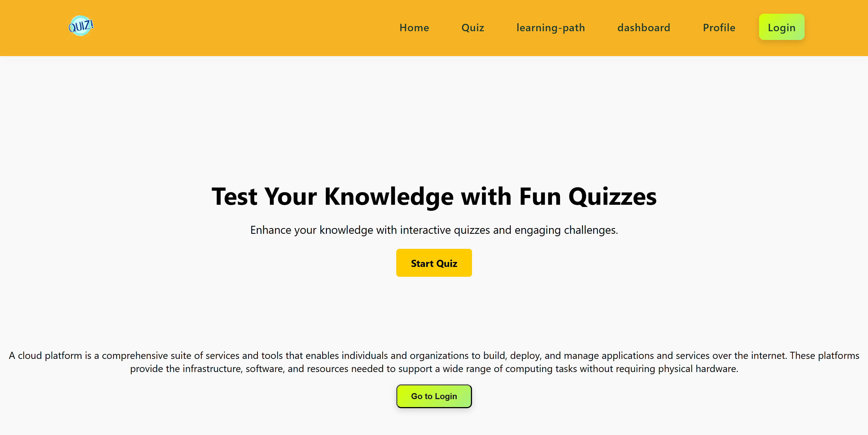

Figure 1.4 UI of Application